Employee Attendance Management System
Project Overview
A full-stack web-based attendance management system developed to manage employee login/logout tracking, shift management, attendance monitoring, and Excel report generation for organizations operating across multiple time zones.

Key Features
1. Employee Attendance Tracking
Employees can securely login/logout.
System automatically calculates total working hours.
Supports Morning and Night shifts.

2. Automatic Attendance Handling
Auto close for unattended sessions.
Automatic OFF record generation for approved leaves.
Late login and emergency logout detection.

3. Role-Based Access
Separate dashboards for:
Admin
Team Leader (TL)
Employee
Protected backend APIs using middleware authorization.

4. Advanced Excel Reporting
Export attendance reports in professional Excel format.
Individual employee sheets.
OFF summary tracking.
Human-readable working hours.

5. Employee Management Module
Add/Edit/Remove employees.
Profile image upload support.
Department and staff management.

6. Time zone - Aware Attendance
Attendance captures employee local system time instead of database server timezone.
Suitable for multinational organizations operating across regions.

7. Security Features
Password hashing using bcrypt.
API protection middleware.
File upload validation.
Rate limiting protection.
Environment variable security.

Technologies Used
Layer | Technology | Purpose
Frontend | React.js | User Interface Development
Frontend Styling | Tailwind CSS | Responsive UI Design and Styling
Backend | Node.js | Server – Side Runtime Environment
Backend Framework | Express.js | API Development & Routing
Database | MySQL | Data Storage & Management
Authentication | Bcrypt | Password Hashing and Security
File Upload | Multer | Employee Profile Image Upload
Security | Helmet | HTTP Security Headers Protection
Security | Express Rate Limit | Prevent Brute Force & API Abuse
API Connection | Fetch API | Frontend-Backend Communication
Version Control | Git | Source Code Management
Package Manager | Npm | Dependency Management
Repository Hosting | GitHub | Project Repository & Collaboration
Development Tools | Vs Code and MySQL Workbench | Code Development Environment & Execution Platform

Database Tables
Table Name | Purpose
Users | Employee, TL and Admin Information
Attendance | Login, Logout, Working Hours and Attendance Records
Shift Settings | Shift Configuration and Active Shift Management
Leave | Employee Leave and Off Management

Project Screenshots
Login Page
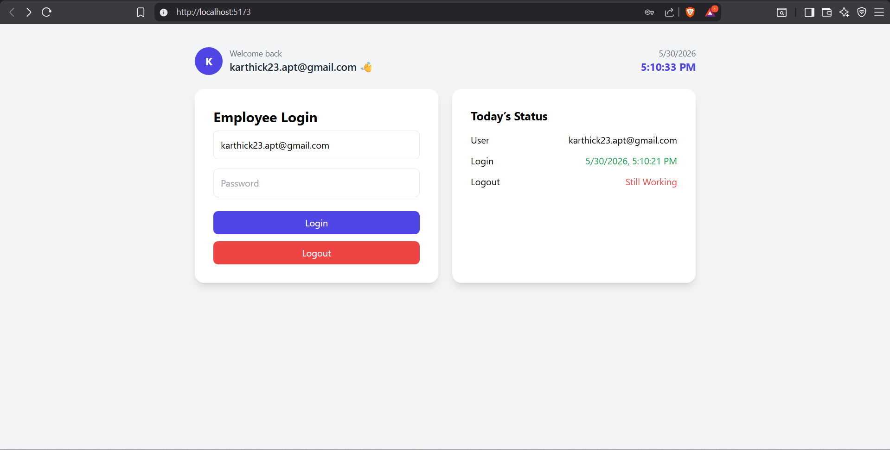

TL Dashboard
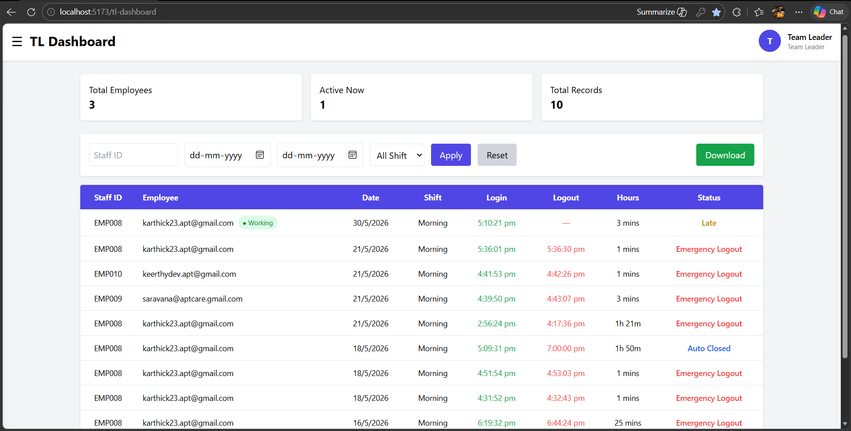
Admin Dashboard
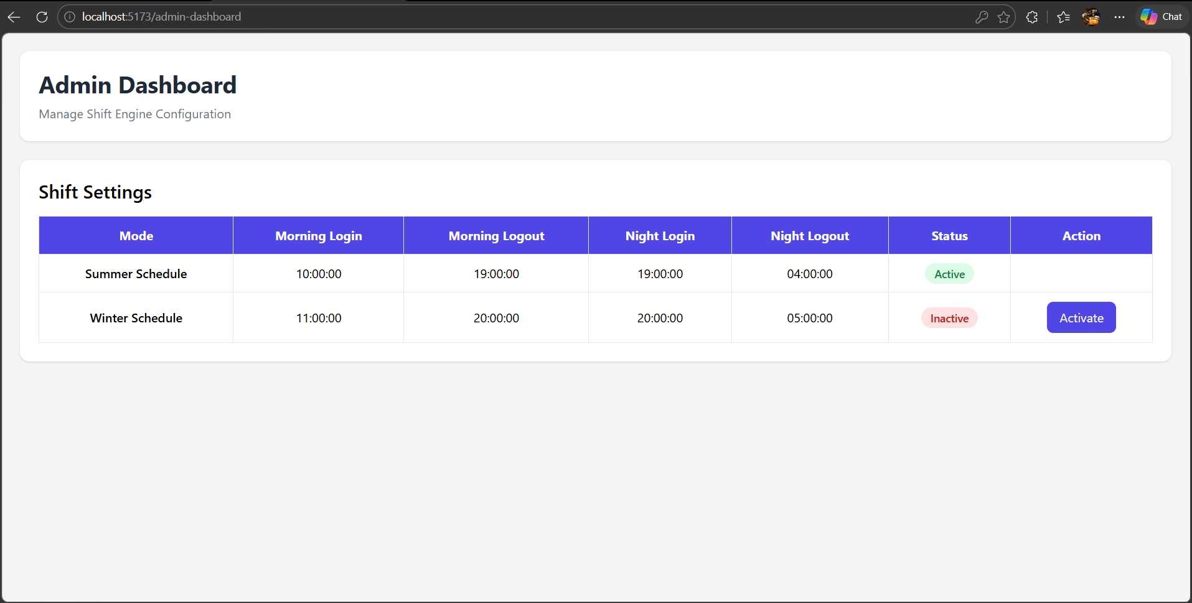

Excel Report
